Project 1.1:

USA Crime Analysis

Problem Statement1:

Loading dataset

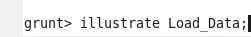

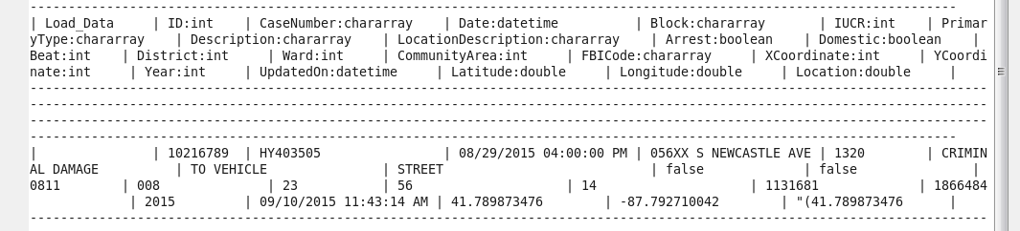

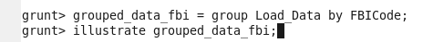

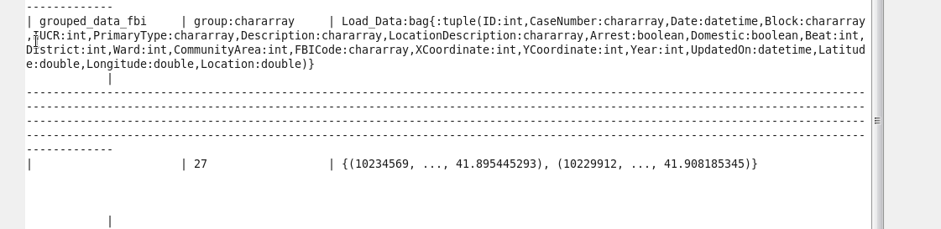

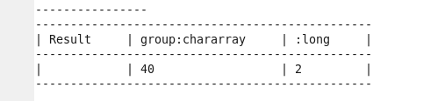

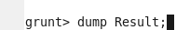

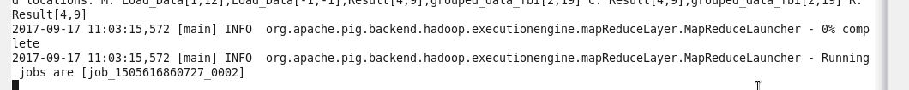
Above Mapreduce jobs were processing for a long time and didn’t show result.

Problem Statement2:

Loading dataset in to variable ‘A’:

Loading required fields (that are required to solve this problem) : Arrest and District in to variable ‘B’:

Illustrating B;

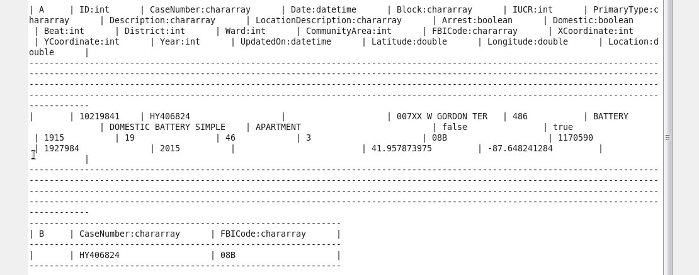

Filtering by FBICode == 32

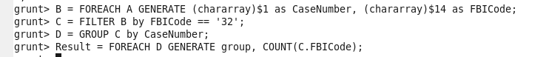

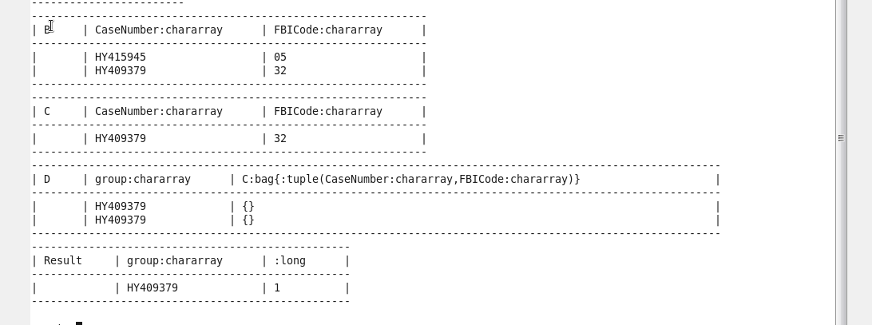

Since dump is taking long time to run, only illustrate command is executed.

Problem Statement3: Pig program to calculate the number of arrests in theft district wise:

Loading dataset in to variable ‘A’:

Illustrating A;

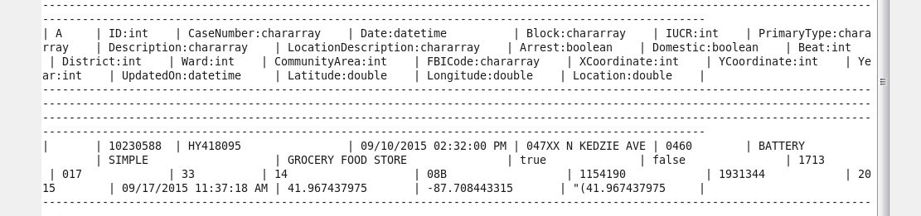

Loading required fields (that are required to solve this problem) : Arrest and District in to variable ‘B’:

Filtering only Arrest theft (Arrest = true):

Grouping District wise:

Number of Arrests theft district wise:

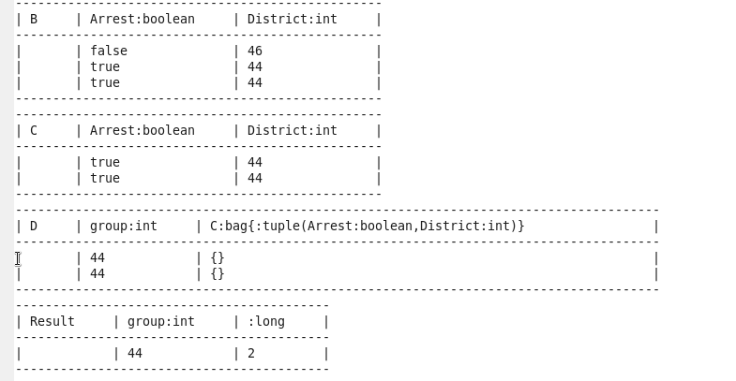

dump Result;

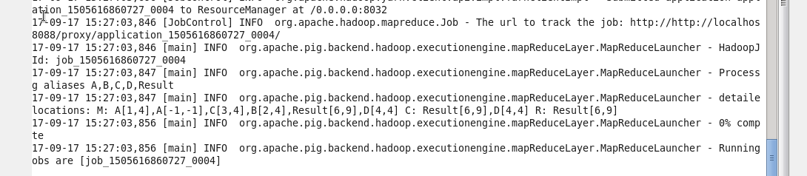

Note: when dump command is executed , its taking long time to process Mapreduce program, as shown in above screenshot.

Problem Statement 4: Pig program to calculate the number of arrests done between October 2014 and October 2015:

Loading dataset in to variable ‘A’:
